Open Vmware and select “Create a New Virtual Machine”.

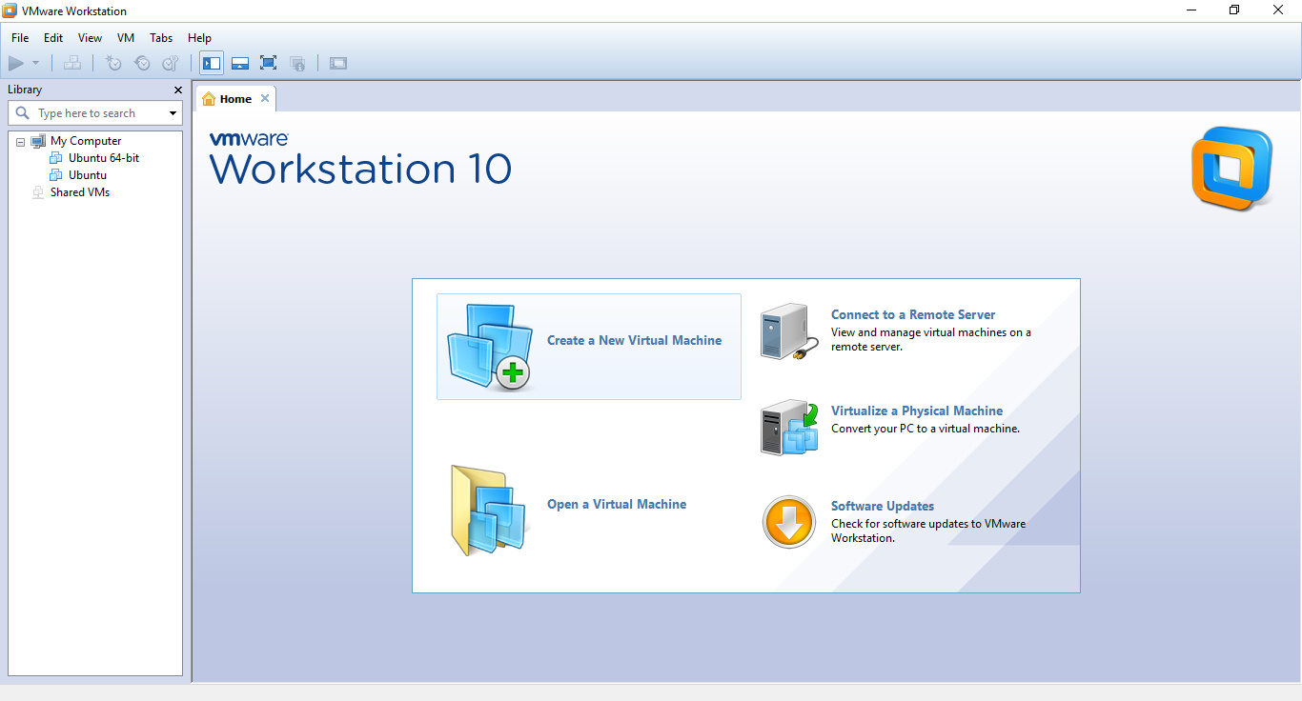

Click Next

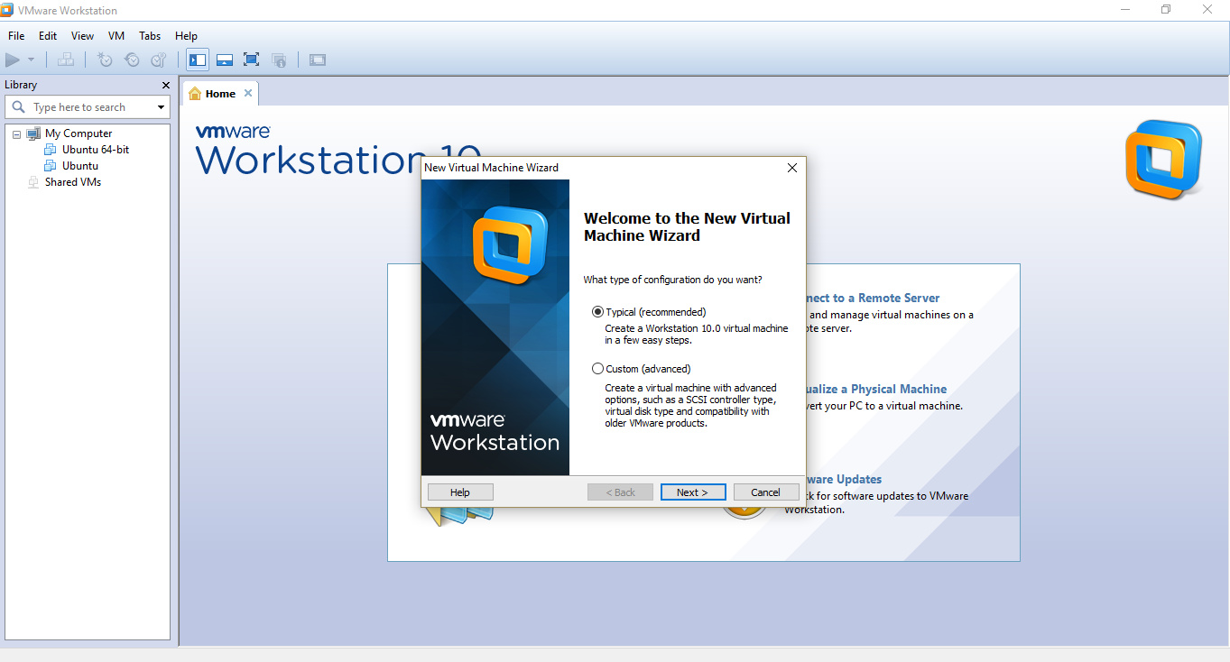

Now click browse and give path to your ubuntu iso file. After that click next.

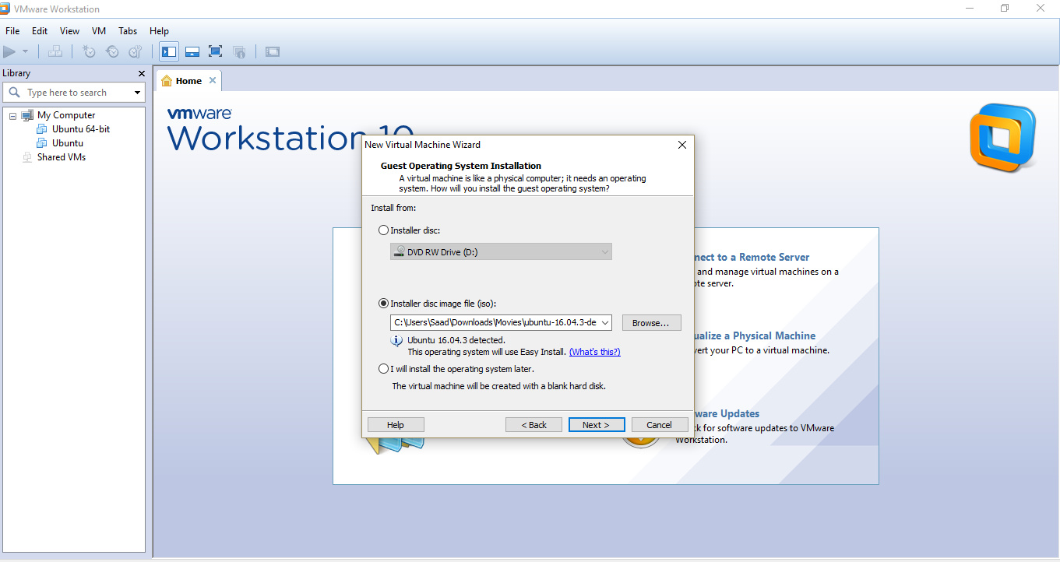

Now enter a new username and password for ubuntu, and click next.

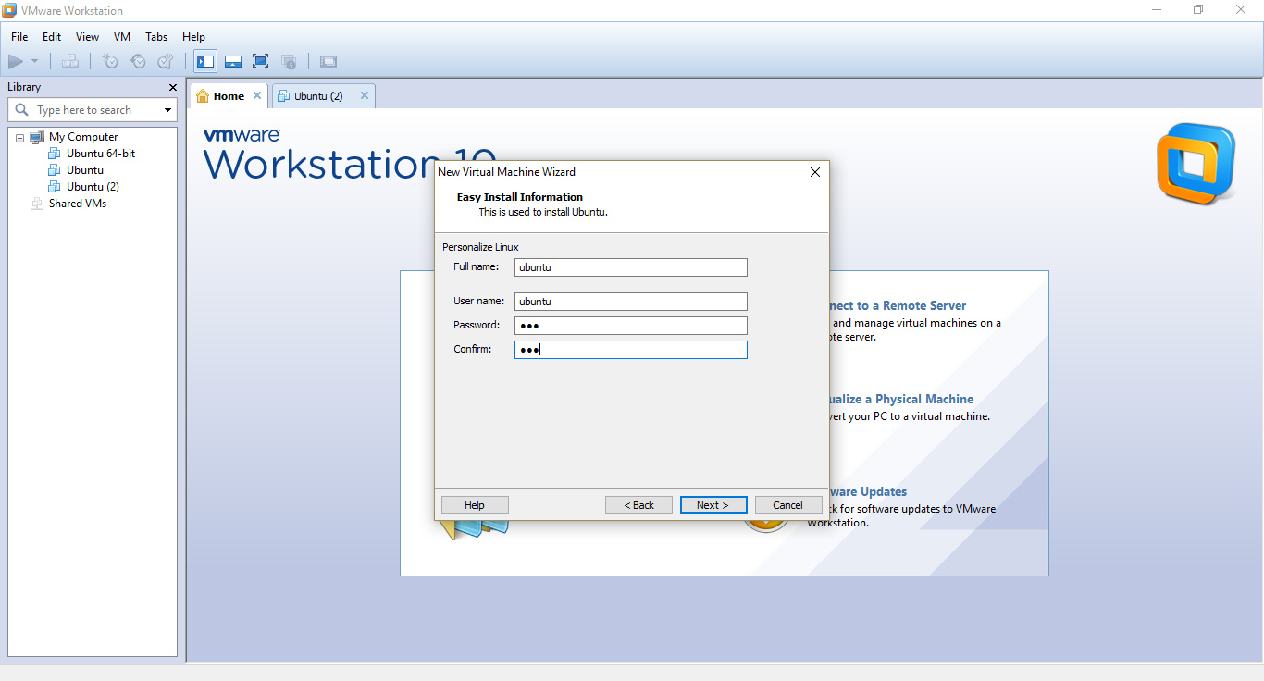

Then keep clicking next. After the wizard has finished, the following screen will appear

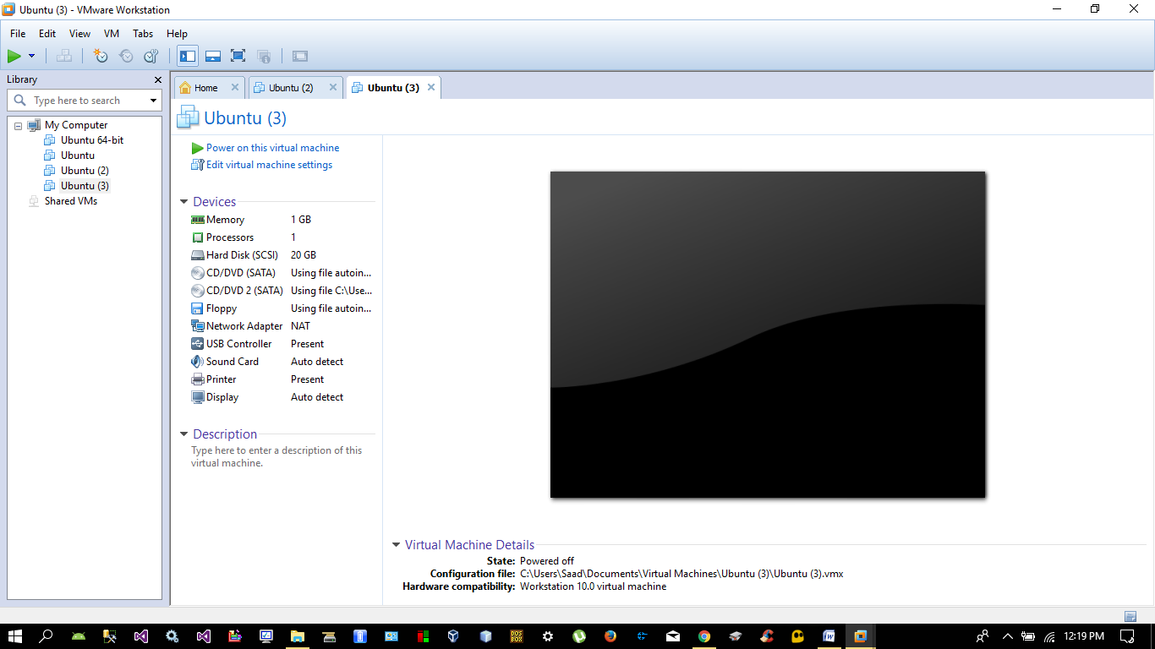

Now “Click Power on This Virtual Machine”. The system will now perform installation of ubuntu. This may take 10-15 minutes.

If ubuntu asks you for username and password, you will have to enter the user name and password that you had chosen earlier during installation wizard.

